✅ Core Logic Behind Video Calling (Step-by-Step)
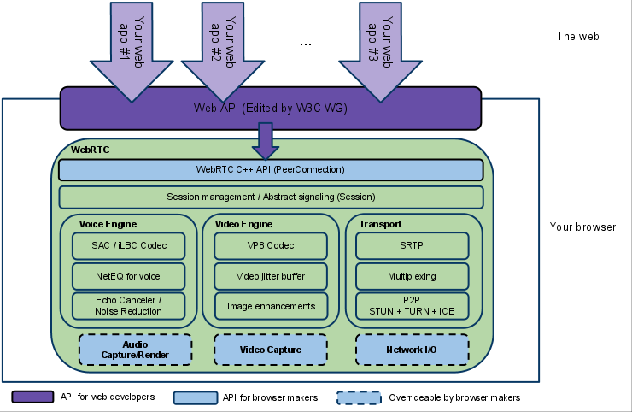
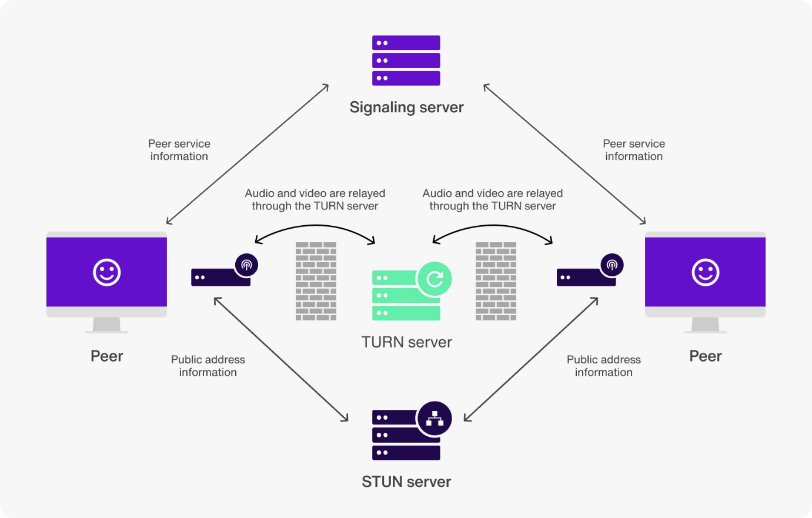

Your app needs 4 main components:

1. Signaling System (To connect two users)
Video call cannot start directly.
First your app must exchange connection details between Caller and Receiver.
You need to send:
- Offer (SDP)
- Answer (SDP)
- ICE Candidates
This is done using:
- WebSocket
- Firebase
- Socket.IO
- Your server’s REST API + polling (not recommended)
✔ Why signaling?
Because two devices cannot directly know:
- What codec to use (H.264, VP8, VP9)
- What resolution
- What STUN/TURN server
- Their public IP and port
So signaling = the “handshake” before actual video starts.

2. WebRTC for P2P Video Transfer
After exchanging SDP + ICE, both users establish a peer-to-peer connection.
✔ WebRTC handles:
- Video streaming
- Audio streaming
- NAT traversal
- Encryption (DTLS + SRTP)
✔ Is it encrypted?
YES, WebRTC is end-to-end encrypted by default.
No extra encryption needed unless you want additional layers.

3. STUN + TURN Servers
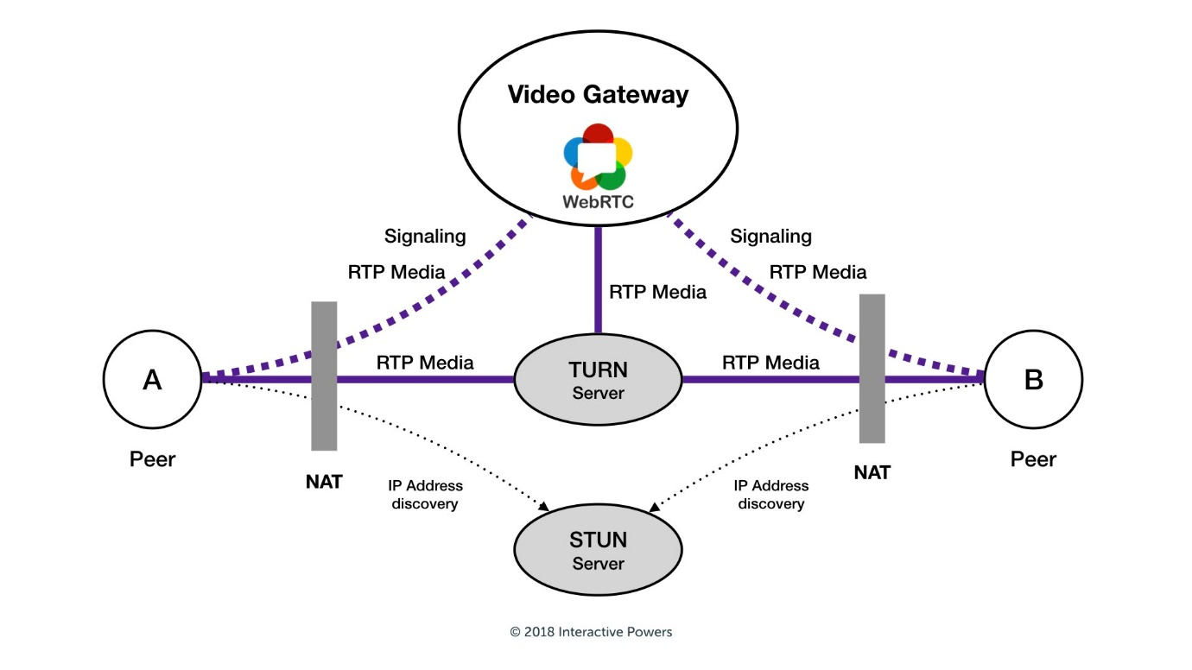
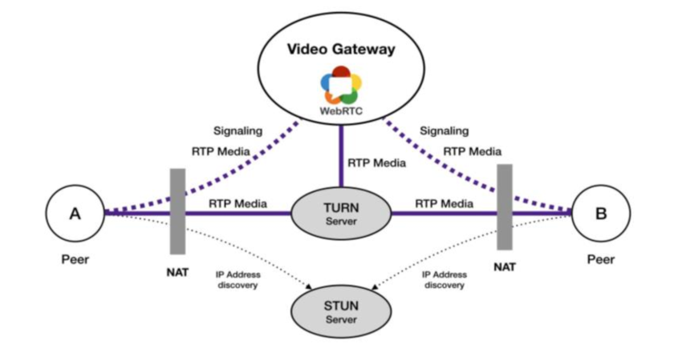
WebRTC needs public IP discovery and fallback relay:
✔ STUN server
- Discovers public IP
- Allows P2P when NAT allows
- Free to use (Google STUN)
✔ TURN server
- Used when P2P fails
- Acts as a relay
- Must be self-hosted (cost ↑)
Apps like WhatsApp, Signal, Telegram use TURN extensively.

4. Media Streams (Camera + Mic)
Once the P2P connection is established, WebRTC sends media streams.
Steps:
- Get camera & mic stream
- Attach stream to WebRTC connection
- WebRTC compresses video using codecs
- WebRTC encrypts packets
- Sends them directly to user’s device

⭐ Full Flow of a Video Call
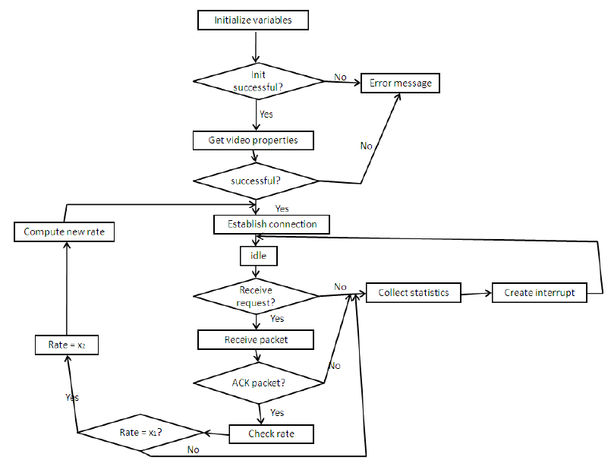

STEP 1 – Caller starts call
- Caller A opens camera
- Creates WebRTC offer (SDP)
- Sends it to User B via signaling server

STEP 2 – Receiver accepts
- User B receives "Incoming Call" via signaling
- B creates Answer (SDP)
- Sends it back through signaling

STEP 3 – Exchange ICE candidates
Both devices exchange:
- IP addresses
- Ports
- Protocols
To check how to connect P2P.

STEP 4 – STUN/TURN connectivity check
- If direct connection possible → P2P
- If not → fallback to TURN relay

STEP 5 – Secure Video Stream Begins
- DTLS handshake
- SRTP encrypted video
- Frame compression
- Live video delivered

🔐 How End-to-End Encryption Works
Signal uses: Double Ratchet + WebRTC E2EE
WhatsApp uses: Signal Protocol + WebRTC E2EE
You can:
Option A: Use WebRTC only (already encrypted)
Simple, recommended.
Option B: Add additional encryption on video frames
More complex (requires encoding/decoding manually).

🧱 Tech Stack You Need
Here are the pieces you must implement:

✔ Frontend:
- WebRTC API (Android/iOS/React Native/Flutter)
- Camera access
- Microphone access
- UI for:
  - Answer
  - Reject
  - Mute
  - Switch camera

✔ Backend:
- Signaling Server
  - WebSocket
  - Socket.IO
  - Node.js/Python/Go
- TURN/STUN Server
  - coturn recommended
  - You must host your own TURN for reliability

🛠 Simple Example Logic (High Level Code)
Caller:
const pc = new RTCPeerConnection(config);
pc.addStream(localStream);

const offer = await pc.createOffer();
await pc.setLocalDescription(offer);

// send offer to server
sendToUserB("offer", offer);
Receiver:
pc.setRemoteDescription(offer);
const answer = await pc.createAnswer();
pc.setLocalDescription(answer);

// send answer back
sendToUserA("answer", answer);
ICE handling:
pc.onicecandidate = (event) => {
if (event.candidate) {
sendToOtherUser("ice-candidate", event.candidate);
}
};

